: Methods for determining series resistance of solar cells (R_{s})

Introduction
Six methods were used to determine the series resistance R_{s} of the solar cell. In Chapter 7, Method I, from which the back contact barrier height was measured relies on the behaviour of R_{s} as a function of T. Therefore, it was important to test these methods to select the most suitable one for the back contact study.
This Appendix describes briefly each method prior to presenting its results. In each result section, selected values of the R_{s} are plotted versus T in order to visualize its behaviour.

Experimental
J-V-T data (both in dark and under various light intensities) for one CSS-CdTe/CdS sample were used in all methods in this Appendix. Both the experimental setup and the procedure for this measurement are described in Section 4.4.2. Details of the sample (sample 290) are presented in Section 6.2.1.

Methods and Results

Method A:
R_{s} can be calculated form the inverse of the slope of the J-V curve at V ~ V_{oc} (for light data), as shown in Figure ‎A.1a. If R_{sh} is high, then equation 2.10 (including J_{L}) can be rearranged for V as

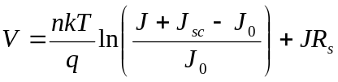 (‎A.1)

by differentiating

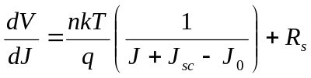 (‎A.2)

by applying the open-circuit conditions (i.e. V = V_{oc} and J = 0)

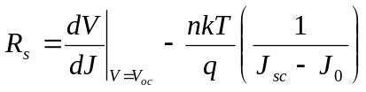 (‎A.3)

The second term in the RHS of equation A.3 is ignorable in comparison to the resistance of the cell [1]. Therefore, for the illuminated J-V curve

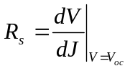 (‎A.4)

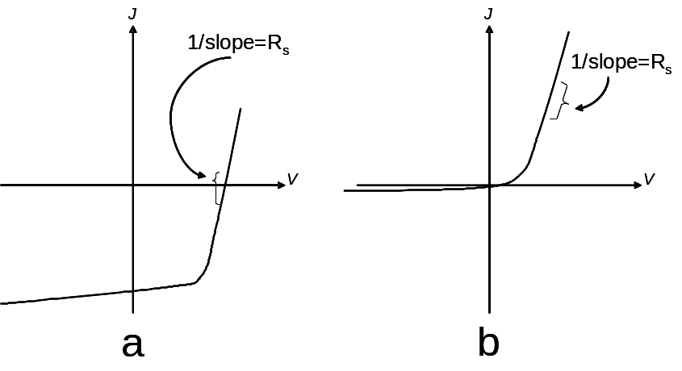

Figure ‎A.1: Typical J-V curves for solar cells under illumination (a) and in dark (b). The figure shows (in each curve) the area from which R_{s} is measured.

Similarly, dark R_{s} can be calculated from dark J-V data by considering the slope of the curve in the forward region as shown in Figure ‎A.1b. Several studies reported using this method in order to get R_{s} [1-4].
Table ‎A.1 and Figure ‎A.2 and Figure ‎A.3 summarize the results of R_{s} both in dark and under illumination for a temperature range of 300 - 200K.

T | R_{s} dark (Ω.cm²) | R_{s} light (Ω.cm²)
300 | 39.02 | 7.95
290 | 50.94 | 9.28
280 | 86.66 | 10.62
270 | 127.23 | 11.7
260 | 253.16 | 12.58
250 | 456.62 | 13.26
240 | 757.58 | 13.42
230 | 1234.73 | 14.31
220 | 2708.24 | 14.63
210 | 6662.18 | 15.93
200 | 15556.72 | 17.9

Table ‎A.1: The R_{s} values extracted by using method A in both dark and light.

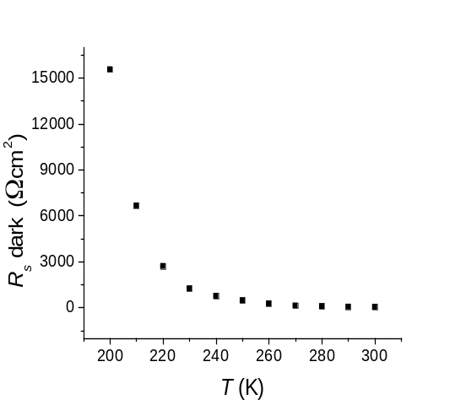
Figure ‎A.2: Dark R_{s} versus T as extracted from Method A.

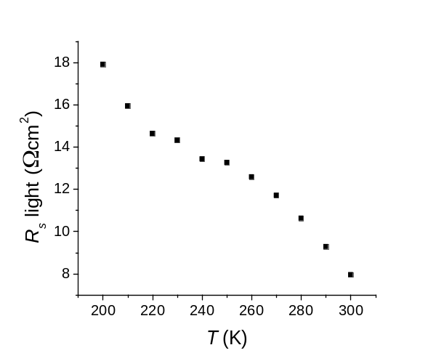
Figure ‎A.3: Light R_{s} versus T as extracted from Method A.

Method B:

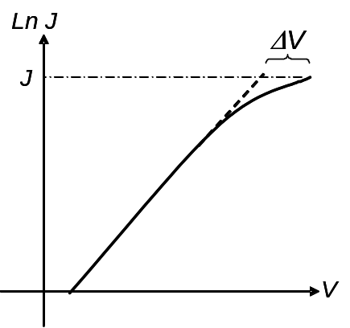

Figure ‎A.4: lnJ versus V plot illustrating the values needed to extract R_{s} by using Method B.

In Section 2.4f and particularly in Figure 2.8, the effect of the R_{s} on the plot lnJ versus V (in forward bias) was illustrated i.e. deviation from linearity. This distortion, therefore, can be used to determine R_{s}. In this method, R_{s} is calculated from

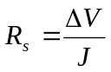 (‎A.5)

where ΔV is the difference in the voltage values between the experimental curve and its linear extrapolation as seen in Figure ‎A.4, and J is the current density corresponding to ΔV. The determination of the R_{s} by this method was reported by several authors e.g. [5, 6]. Table ‎A.2 and Figure ‎A.5 show the results of dark R_{s} as a function of T.

T | R_{s} dark (Ω.cm²)
300 | 31.59
290 | 42.37
280 | 71.06
270 | 124.66
260 | 271.94
250 | 518.87
240 | 974.37
230 | 1642.29
220 | 3666.45
210 | 9030.51
200 | 18812.43

Table ‎A.2: The R_{s} values extracted by using Method B in dark.

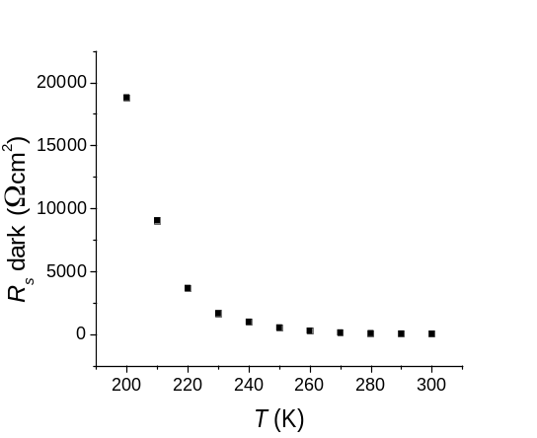
Figure ‎A.5: Light R_{s} versus T as extracted from Method B.

Only dark values of the R_{s} were determined by using this method. Light data were not analyzed due to the impossibility of taking logarithm for negative values of the current for V < V_{oc}. Furthermore, roll-over dominated current for all V > V_{oc}.

Method C:
This method was proposed by Singh and Singh [7], in which the maximum power point (P_{max}) was used. At this point

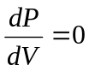 (‎A.6)

where P is the power generated by the cell, and

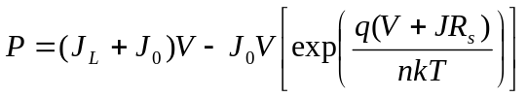 (‎A.7)

Equation A.6 is equivalent to

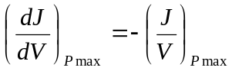 (‎A.8)

Using equation A.7 and differentiating equation 2.10 (including J_{L} and assuming that R_{sh} is sufficiently high)

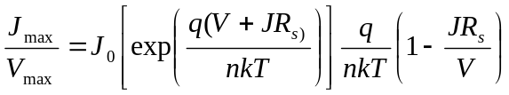 (‎A.9)

where, V_{max} and J_{max} are voltage and current corresponding to the maximum power point generated by the solar cell. If J₀ << J_{L}, then by using equations A.6 and A.7, equation A.9 becomes

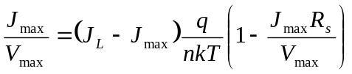 (‎A.10)

or

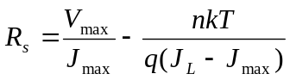 (‎A.11)

The approximation that J_{L}= J_{sc} was used in calculations. It is seen from equation A.11 that this method is not applicable for the dark data due to the existence of V_{max} and J_{max} in the equation. Table ‎A.3 presents R_{s} values for all the light intensity used in this study. Figure ‎A.6 shows R_{s} results corresponding to the 100 % illumination as a function of T.

R_{s} (Ω.cm²)
T | 100% light | 79% light | 50% light | 20% light | 10% light
300 | 63.59 | 80.01 | 121.96 | 287.09 | 498.82
290 | 78.13 | 97.49 | 148.91 | 365.69 | 675.32
280 | 80.1 | 100.81 | 153.59 | 379.66 | 687.1
270 | 82.32 | 103.45 | 157.36 | 379.1 | 723.15
260 | 84.27 | 104.89 | 158.45 | 382.51 | 704.79
250 | 84.36 | 105.69 | 160 | 395.21 | 724.68
240 | 83.7 | 105.57 | 157.84 | 387.83 | 710.65
230 | 84.65 | 105.32 | 159.49 | 381.97 | 731.75
220 | 84.2 | 105.88 | 159.52 | 380.22 | 699.58
210 | 88.08 | 110.34 | 165.84 | 393.97 | 783.33
200 | 90.25 | 113.89 | 167.84 | 397.1 | 736.69

Table ‎A.3: The R_{s} data extracted by using Method C for different light intensities.

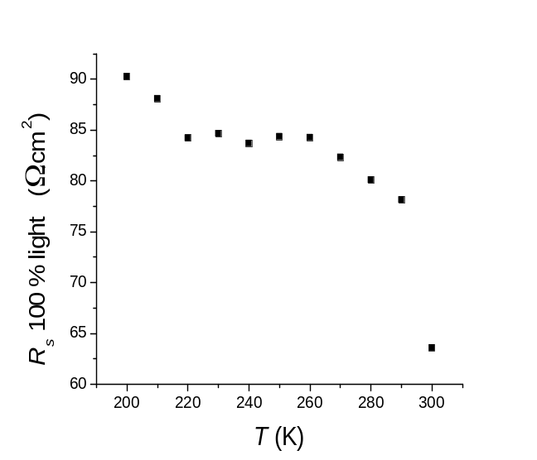
Figure ‎A.6: The results of R_{s} for the cell under 100 % illumination (AM1.5) versus T as extracted from Method C.

Method D:
Method D uses both dark and light J-V data to extract R_{s}. If R_{sh} is high then equation 2.8 can be used to express dark current J_{d} as [8]

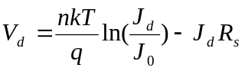 (‎A.12)

where V_{d} is the corresponding voltage for J_{d}. If J_{L} >> J₀, then equation 2.31 becomes

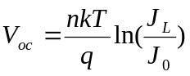 (‎A.13)

By subtracting equation A.13 from equation A.12 (and considering J_{L} = J_{sc})

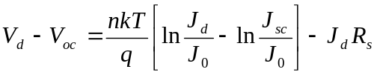 (‎A.14)

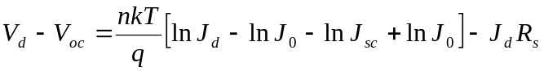 (‎A.15)

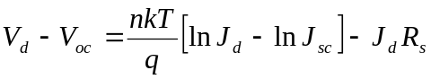 (‎A.16)

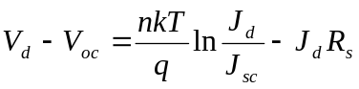 (‎A.17)

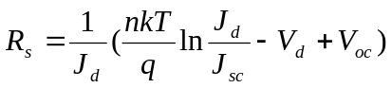 (‎A.18)

V_{d} was chosen to be 1 V, which is the maximum value of applied V. The reason of this choice was that R_{s} effect is usually more pronounced in high V i.e. maximum R_{s} effect. The results obtained from this method are summarized in Table ‎A.4 and shown in Figure ‎A.7.

T | R_{s} (Ω.cm²)
300 | 38.87
290 | 67.4
280 | 111.04
270 | 192.04
260 | 323.34
250 | 527.29
240 | 730.82
230 | 1023.32
220 | 1216.3
210 | 1383.52
200 | 1396.62

Table ‎A.4: The R_{s} data extracted by using Method D.

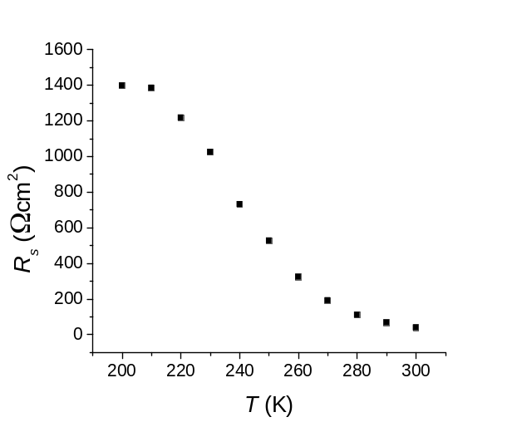
Figure ‎A.7 The results of R_{s} extracted from Method D as a function of T.

Method E:
This method was proposed by El-Adawi and Al-Nuaim [9]. Equation A.1 is rearranged to be

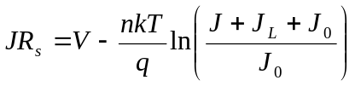 (‎A.19)

By applying this equation to any two points on the J-V curve (and assuming that J₀ is negligible compared to J_{L}), and then subtract the resulting equations from each other R_{s} can be expressed as

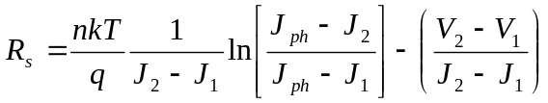 (‎A.20)

where J₁, J₂, V₁, and V₂ are current densities and voltages for the two points selected from J-V curve respectively. R_{s} was measured for data collected under different light intensities as shown in Table ‎A.5. The result of R_{s} versus T for 100 % illumination is shown in Figure ‎A.8.

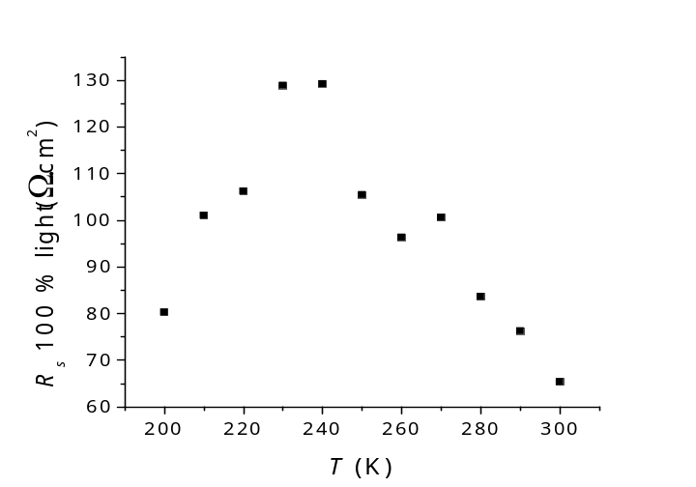

Figure ‎A.8: The results of R_{s} (Method E) for the cell under 100 % illumination (AM1.5) versus T.

R_{s} (Ω.cm²)
T | 100% light | 79% light | 50% light | 20% light | 10% light
300 | 65.34 | 80.41 | 124.16 | 230.09 | 307.11
290 | 76.25 | 101.18 | 160.69 | 271.78 | 390.12
280 | 83.61 | 115.85 | 168.01 | 382.07 | 531.7
270 | 100.58 | 127.62 | 215.816 | 443.36 | 769.67
260 | 96.31 | 162.9 | 233.36 | 589.45 | 943.17
250 | 105.41 | 148.19 | 272.18 | 527.35 | 1059.23
240 | 129.2 | 149.5 | 289.24 | 724.16 | 1219.16
230 | 128.85 | 147.5 | 284.94 | 872.61 | 1362.8
220 | 106.21 | 135.12 | 241.24 | 762.87 | 1375.88
210 | 101 | 122.91 | 236.89 | 651.55 | 1519.1
200 | 80.25 | 104.95 | 215.39 | 600.39 | 1504.98

Table ‎A.5: The R_{s} data extracted by using Method E for different light intensities.

Method F:
R_{s} was measured by using a characterizing software called CurVA, which was created and developed in Colorado State University. The theoretical background of CurVa is based on a paper published by Hegedus and Shafarman [10]. By recalling equation 2.10, and considering the case where 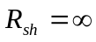 and R_{s} has a finite value, it can be written that

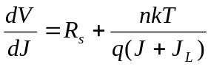 (‎A.21)

Therefore, R_{s} is the intercept of dV/dJ versus (J + J_{L})⁻¹ plot. R_{s} was evaluated for both dark and 100 % illuminated data by using CurVA. The results of these curves are summarized in Table ‎A.6, and the dark results are shown in Figure ‎A.9.

T | R_{s} dark  (Ω.cm²) | R_{s} light  (Ω.cm²)
300 | 19.46 | 0.69
290 | 23.7 | -2.58
280 | 80.97 | 4.17
270 | 35.03 | -5.78
260 | 50.86 | -0.07
250 | 120.79 | 2.42
240 | 177.23 | 0.47
230 | 349.46 | 4.5
220 | 600.97 | 7.14
210 | 1153.69 | 4.69
200 | -704.36 | 2.7

Table ‎A.6: The R_{s} values extracted by using Method F in both dark and light.

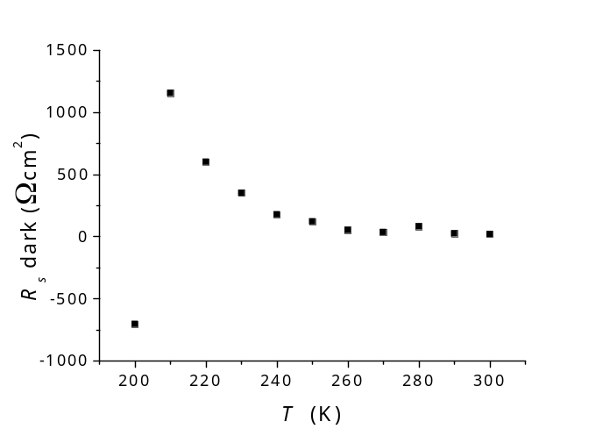
Figure ‎A.9: Dark R_{s} versus T as extracted from method F.

Discussion and conclusion
R_{s} values varied massively depending on the method that they were extracted from. A similar behaviour was reported by Sabry and Ghitas [11], who investigated seven different methods for determining R_{s}. The variation was attributed to several factors such as the theoretical model used (e.g. one or two diode models), the assumption of a constant ideality factor with variable temperature and illumination and the finite of R_{sh}. Those factors may be the same source for the variation of results represented above, for example, R_{sh} was always considered to be infinite in this work.
The variation in R_{s} in Sabry and Ghitas’s work was (for some models) ~ 2 orders of magnitude, for the same T and illumination. Moreover, R_{s} did not only vary vastly among models but also had: a) negative values, and b) opposite trends with both illumination and T. These issues were experienced in this work as shown in the figures above. For example, beside the variation in values as shown in the tables above, R_{s} extracted using Method A behaved differently with T compared to values extracted using Method E, seen in Figure ‎A.3 and Figure ‎A.5 respectively. In addition, Model F gave negative values for R_{s}, see Table ‎A.6.
Sabry and Ghitas concluded that there is no accurate model for evaluating R_{s}, which can be concluded from this work as well. However, Model A was chosen to determine R_{s} for the back contact study in Chapter 7 due to: a) simplicity, b) reasonable results and c) consistency of R_{s} behaviour with T for dark data (see Chapter 7 for more details).

Reverences for appendix
[1] J. Nelson, The Physics of Solar Cells, 2 ed., Imperial College Press, London, (2003).
[2] S. N. A. Alamri, PhD Thesis, Durham University, Durham, (1999).
[3] H. M. Al-Allak, A. W. Brinkman, H. Richter and D. Bonnet, Journal of Crystal Growth 159 (1996) 910-915.
[4] P. Mialhe, A. Khoury and J. P. Charles, Physica Status Solidi (a) 83 (1984) 403-409.
[5] A. S. Riad, S. Darwish and H. H. Afify, Thin Solid Films 391 (2001) 109-116.
[6] E. Radziemska, Energy Conversion and Management 46 (2005) 1485-1494.
[7] V. N. Singh and R. P. Singh, J. Phys. D: Appl. Phys. 16 (1983) 1823-1825.
[8] D. Schroder, Semiconductor Material and Device Characterization, Third Edition ed., John Wiley & Sons (2006).
[9] M. K. El-Adawi and I. A. Al-Nuaim, Vacuum 64 (2001) 33-36.
[10] S. S. Hegedus and W. N. Shafarman, Progress in Photovoltaics: Research and Applications 12 (2004) 155-176.
[11] M. Sabry and A. E. Ghitas, Journal of Solar Energy Engineering 129 (2007) 331-335.

